**Department of Electronics and Telecommunication Engineering**

**Module wise University Questions**

**(First Half of 2023)**

**Class/Sem: BE/VIII Branch: EXTC**

**Subject: OC**

**Module 3: Optical Communication Systems**

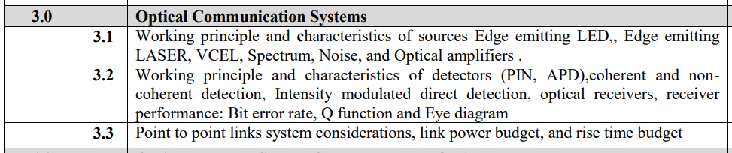

**Dec 2019**

1. Differentiate LED and LASER. [5m]
2. Write short note on (ii) Quantum Well Laser [5m]
3. Explain in detail working, principles of RAPD. Why it is called reach through APD and compare its working with PIN diode? [10m]
4. Write short note on quantum well laser. [05]
5. Differentiate LED and laser sources [05]
6. Explain in detail working principle of RAPD. Why it is called reach through APD and compare its working with PIN diode [08]
7. An analog optical fiber system employs an LED which emits3 dBm mean optical powerinto air. However, a coupling loss of 17.5 dB is encountered when launching into a fibercable. The fiber cable which extends for 6 km without repeaters exhibits a loss of 5 dB.km-1It is spliced every 1.5 km with an average loss of 1.1 dB per splice. In addition, there is aconnector loss at the receiver of 0.8 dB. The PIN-FET receiver has a sensitivity of - 54 dBmat the operating bandwidth of the system. Assuming there is no dispersion-equalizationpenalty, perform an optical power budget for the system and establish a safety margin[10]
8. Explain working principle of EDFA with diagram [10]

**May 2019**

1. Explain in detail working principle of PIN photodetector. Explain its merits and demerits [10m]

**Dec 2018**

1. Explain in detail working principle of Avalanche photodetector. Explain its merits and demerits [10m]
2. Explain in detail working principle of Avalanche photodetector. Explain its merits and demerits.[10]
3. What are optical amplifiers. Explain different types of front end amplifiers [10]

**May 2018**

1. Differentiate LED and LASER sources [5m]
2. Explain principle of APD photodetector. [5m]
3. Explain principle of working of APD photodetector[05]

**Dec 2017**

1. Explain working principle of LASER source used in optical fiber communication [5m]
2. Differentiate APD and PIN photodetectors [5m]
3. Differentiate PIN and APD photodiodes [05]
4. Derive an expression for Link power budget analysis of optical fiber [07]
5. Explain EDFA amplifier. Mention its advantages [08]

**May 2017**

1. Differentiate LED and LASER sources [5m]
2. Derive an expression for responsivity of PIN photodiode. Differentiate PIN and RAPD photodiodes. [8m]
3. Derive an expression for responsivity of PIN photodiode [04]
4. Differentiate PIN and APD photodiodes [05]
5. Explain front end amplifiers in optical communication [05]

**Dec 2016**

1. Explain the basic working principle of LASERs [5m]

**May 2016**

1. Write short note on: Link budget[05]

**Dec2015**

1. Differentiate LED and LASER sources [5m]
2. Explain in detail working principle of RAPD. Why it is called reach through APD and compare its working with PIN diode. [8m]
3. Highlight need of link budget what are the strategies of link budget in optical communication network.[10]
4. Explain in detail working principle of RAPD. Why it is called reach through APD and compare its working with PIN diode [08]
5. Derive an expression for responsitivity of PIN photodiode [05]
6. Write a short note on link power budget [10]

**Dec 2014**

1. Short note: Coherent and Non coherent optical communication.[10]
2. Compare direct band gap and indirect band gap semiconductors.[05]
3. Draw and explain block diagram of Optical receiver along with various noise sources and relevant equations.[10]
4. Explain all aspects of link power budget and rise time budget.[10]
5. Short note: Optical bandwidth and electrical bandwidth.[05]

**May 2014**

1. Short note: Optical Amplifiers[05]
2. With the help of receiver configuration circuit diagram, explain the working of optical receiver. Also derive the expression for output.[10]

**Dec 2013**

1. Give the structure of surface emitting LED. Compare with an edge emitting LED.[10]
2. Explain spontaneous emission and stimulated emission.[05]
3. Briefly discuss the possible sources of noise in optical fiber receiver. Describe in detail. What is meant by quantum noise? Consider this phenomenon with regard to
4. Digital signaling (ii) Analog transmission.
5. Describe in detail. What is meant by quantum noise?[10]

**May 2013**

1. What is the basic principle on which optical source work? With the help of a LED structure explains its working.[10]
2. State the difference between LED and LASER.[05]
3. What are the desirable requirements of a good fiber optic connector? What are the lensing schemes for coupling improvements?[10]
4. Differentiate between spontaneous and stimulated emissions.[05]

**May 2012**

1. Explain with a neat sketch the two categories of front-end amplifiers used in optical fiber communication systems.[05]
2. List all the parameters that contribute to photo current gain of APD[05]
3. Describe in detail. What is meant by quantum noise?[10]
4. Draw the current optical power output curve for Fabry - Perot Laser and explain the relationships.[05]
5. Briefly discuss the possible sources of noise in optical fiber receiver. Describe in detail. What is meant by quantum noise? Consider this phenomenon with regard to

### (i) Digital signaling (ii) Analog transmission. [10]

1. Derive an expression for responsivity of an intrinsic photo detector in terms of quantum efficiency and wavelength[05]
2. In a point-to-point communication link it is given that launched power is -10 dBm, receiver sensitivity is -40 dBm and the length of the link is 10km.[10]
3. Find the safety margin. If the fiber bandwidth is 1000 MHz km what is the maximum permissible data rate.[10]
4. What do you understand by double heterostructure? State its limitations.[05]
5. List all the parameters that contribute to photo current gain of APD.[05]